Syllabus:
Graphs Algorithms: Connected Components in a graph, Finding Bridges in a Graph and Finding Articulation Point in a Graph, Maximum Flow Algorithms, Lowest Common Ancestor.
Topological Sort: Introduction, Applications: Parallel Courses, Course Schedule.

Graphs Algorithms:
Applications:
- Connected Components in a graph.
- Finding Bridges in a Graph.
- Finding Articulation Point in a Graph.
- Maximum Flow Algorithms.
- Lowest Common Ancestor.

- Connected Components in a graph
- A connected component or simply component of an undirected graph is a subgraph in which each pair of nodes is connected with each other via a path.
- Let’s try to simplify it further, though. A set of nodes forms a connected component in an undirected graph if any node from the set of nodes can reach any other node by traversing edges. The main point here is reachability.
- In connected components, all the nodes are always reachable from each other.
- Given an undirected graph, it’s important to find out the number of connected components to analyze the structure of the graph – it has many real-life applications. We can use either DFS or BFS for this task.
Example: The undirected graph has two connected components shown below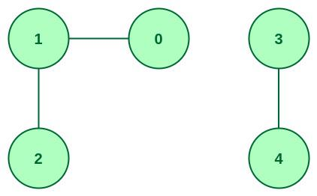
Input : 5 3 // number of cities(5){(0,1,2,3,4)} and routes(3)
0 1 //city1, city2 connections
1 2
3 4
Output : 2
Explanation: There are 2 different connected components. They are {0, 1, 2} and {3, 4}.
- In this section, we’ll discuss a DFS-based algorithm that gives us the number of connected components for a given undirected graph:
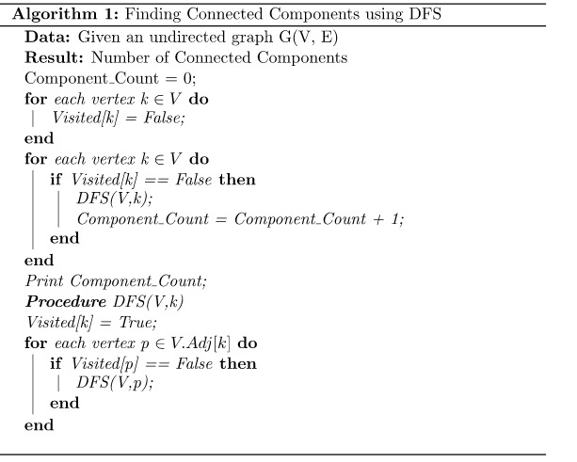

Java Program for Finding Connected Components in graph using DFS:

ConnectedComponents.java

import java.util.*;
class ConnectedComponents {
public int countComponents(int n, int[][] edges) {
List<List<Integer>> adjacencyList = new ArrayList<>();
for (int i = 0; i < n; i++) {
adjacencyList.add(new ArrayList<>());
}

for (int[] edge : edges) {
int u = edge[0];
int v = edge[1];
adjacencyList.get(u).add(v);
adjacencyList.get(v).add(u);
}
boolean[] visited = new boolean[n];
int components = 0;

for (int i = 0; i < n; i++) {
if (!visited[i]) {
dfs(adjacencyList, i, visited);
components++;
}
}
return components;
}
private void dfs(List<List<Integer>> adjacencyList, int start, boolean[] visited) {
Stack<Integer> stack = new Stack<>();
stack.push(start);
visited[start] = true;
while (!stack.isEmpty()) {
int node = stack.pop();
for (int neighbor : adjacencyList.get(node)) {
if (!visited[neighbor]) {
stack.push(neighbor);
visited[neighbor] = true;
}
}
}
}
public static void main(String[] args) {
Scanner sc = new Scanner(System.in);
int n = sc.nextInt();
int e = sc.nextInt();
int[][] edges = new int[e][2];
for (int i = 0; i < e; i++) {
for (int j = 0; j < 2; j++) {
edges[i][j] = sc.nextInt();
}
}
int result = new ConnectedComponents().countComponents(n, edges);
System.out.println(result);
}
}

==== Test cases ====
case =1
input =5 6
0 1
0 2
2 3
1 2
1 4
2 4
output =1

case =2
input =5 4
0 1
0 2
1 2
3 4
output =2

Java Program for Finding Connected Components in graph using BFS:

ConnectedComponents.java

import java.util.*;
class ConnectedComponents {
public int countComponents(int n, int[][] edges) {
List<List<Integer>> adjacencyList = new ArrayList<>();
for (int i = 0; i < n; i++) {
adjacencyList.add(new ArrayList<>());
}

for (int[] edge : edges) {
int u = edge[0];
int v = edge[1];
adjacencyList.get(u).add(v);
adjacencyList.get(v).add(u);
}
boolean[] visited = new boolean[n];
int components = 0;

for (int i = 0; i < n; i++) {
if (!visited[i]) {
bfs(adjacencyList, i, visited);
components++;
}
}
return components;
}
private void bfs(List<List<Integer>> adjacencyList, int start, boolean[] visited) {
Queue<Integer> queue = new LinkedList<>();
queue.offer(start);
visited[start] = true;

while (!queue.isEmpty()) {
int node = queue.poll();
for (int neighbor : adjacencyList.get(node)) {
if (!visited[neighbor]) {
visited[neighbor] = true;
queue.offer(neighbor);
}
}
}
}
public static void main(String[] args) {
Scanner sc = new Scanner(System.in);
int n = sc.nextInt();
int e = sc.nextInt();
int[][] edges = new int[e][2];

for (int i = 0; i < e; i++) {
for (int j = 0; j < 2; j++) {
edges[i][j] = sc.nextInt();
}
}
int result = new ConnectedComponents().countComponents(n, edges);
System.out.println(result);
}
}

Sample Input:
5 6
0 1
0 2
2 3
1 2
1 4
2 4

Sample Output:
1

- FindingBridges in a Graph:

- Given an undirected graph of V vertices and E edges. Our task is to find all the bridges in the given undirected graph.
- A bridge in any graph is defined as an edge which, when removed, makes the graph disconnected (or more precisely, increases the number of connected components in the graph).
- The algorithm described here is based on DFS and has O(N+M) complexity, where N is the number of vertices and M is the number of edges in the graph.
- For Example: If the given graph is :
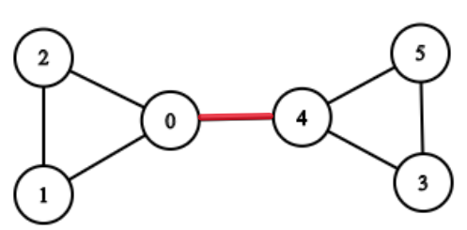
- The edge between 0 and 4 is the bridge because if the edge between 0 and 4 is removed, then there will be no path left to reach from 0 to 4.and makes the graph disconnected, and increases the number of connected components.
- Note :
  - There are no self-loops(an edge connecting the vertex to itself) in the given graph.

  - There are no parallel edges i.e no two vertices are directly connected by more than 1 edge.

Sample Input-1:
---------------
4 3 //No. of nodes =4 {0,1,2,3} & No of Edges=3
0 1
0 2
1 3

Sample Output-1:
----------------
1 3
0 1
0 2
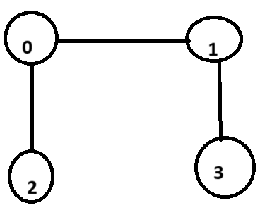

Java Program for Finding Bridges in undirected graph using DFS:
FindingBridges.java
import java.io.*;
import java.util.*;
import java.util.LinkedList;
class FindingBridges {
private int V;
private LinkedList<Integer>[] adj;
int time = 0;
FindingBridges(int v) {
V = v;
adj = new LinkedList[v];
for (int i = 0; i < v; ++i)
adj[i] = new LinkedList<>();
}
void addEdge(int v, int w) {
adj[v].add(w);
adj[w].add(v);
}
void bridgeUtil(int u, boolean visited[], int disc[], int low[], int parent[]) {
visited[u] = true;
disc[u] = low[u] = ++time;
for (int v : adj[u]) {
if (!visited[v]) {
parent[v] = u;
bridgeUtil(v, visited, disc, low, parent);

low[u] = Math.min(low[u], low[v]);
if (low[v] > disc[u])
System.out.println(u + " " + v);
} else if (v != parent[u]) {
low[u] = Math.min(low[u], disc[v]);
}
}
}
void bridge() {
boolean visited[] = new boolean[V];
int disc[] = new int[V];
int low[] = new int[V];
int parent[] = new int[V];
for (int i = 0; i < V; i++) {
parent[i] = -1;
visited[i] = false;
}
for (int i = 0; i < V; i++)
if (!visited[i])
bridgeUtil(i, visited, disc, low, parent);
}
public static void main(String args[]) {
Scanner sc = new Scanner(System.in);
int v = sc.nextInt();
int e = sc.nextInt();
FindingBridges g = new FindingBridges(v);
for (int i = 0; i < e; i++) {
int end1 = sc.nextInt();
int end2 = sc.nextInt();
g.addEdge(end1, end2);
}

g.bridge();
}
}

3.Finding Articulation Point in a Graph:
A vertex is said to be an articulation point in a graph if removal of the vertex and associated edges disconnects the graph. So, the removal of articulation points increases the number of connected components in a graph.

- Articulation points are sometimes called cut vertices. The main aim here is to find out all the articulations points in a graph.
- Example: Given an undirected graph G, then find all the articulation points in the graph.

Input: { Below Graph}
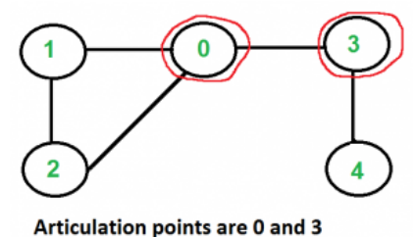
Output = 0,3

Algorithm:
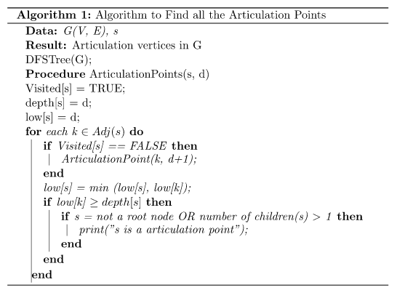
- This is a DFS based algorithm to find all the articulation points in a graph. Given a graph, the algorithm first constructs a DFS tree.
- Initially, the algorithm chooses any random vertex to start the algorithm and marks its status as visited. The next step is to calculate the depth of the selected vertex. The depth of each vertex is the order in which they are visited.

- Next, we need to calculate the lowest discovery number. This is equal to the depth of the vertex reachable from any vertex by considering one back edge in the DFS tree. An edge is a back edge if it is an ancestor of edge but not part of the DFS tree, but the edge is a part of the original graph.

- After calculating the depth and lowest discovery number for the first picked vertex, the algorithm then searches for its adjacent vertices. It checks whether the adjacent vertices are already visited or not. If not, then the algorithm marks it as the current vertex and calculates its depth and lowest discovery number.

Graph 1: (Articulation Point Graph 1:0,3)
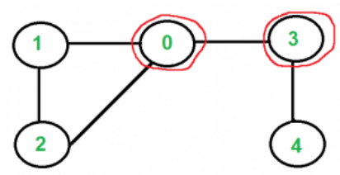

Graph 2:(Articulation Point Graph 2: 1,2)
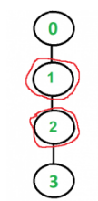

Graph 3: (Articulation Point Graph 3: 1)
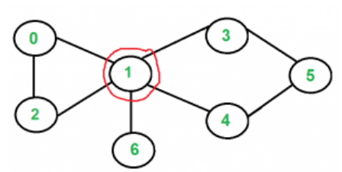

Java Program for Finding Articulation Points

ArticulationPoint.java

import java.util.*;
class ArticulationPoint {
static int time;
static void addEdge(ArrayList<ArrayList<Integer>> adj, int u, int v) {
adj.get(u).add(v);
adj.get(v).add(u);
}
static void APUtil(ArrayList<ArrayList<Integer>> adj, int u,
boolean visited[], int disc[], int low[],
int parent[], boolean isAP[]) {

// Count of children in DFS Tree
int children = 0;
// Mark the current node as visited
visited[u] = true;
// Initialize discovery time and low value
disc[u] = low[u] = ++time;
// Go through all vertices adjacent to this
for (Integer v : adj.get(u)) {
// If v is not visited yet, then make it a child of u in DFS tree and recur for it
if (!visited[v]) {
parent[v] = u;
children++;
APUtil(adj, v, visited, disc, low, parent, isAP);
// Check if the subtree rooted with v has a connection to one of the ancestors of u
low[u] = Math.min(low[u], low[v]);
// If u is not root and low value of one of its child is more than discovery value of u.
if (parent[u] != -1 && low[v] >= disc[u]) {
isAP[u] = true;
}
}
// Update low value of u for parent function calls.
else if (v != parent[u]) {
// System.out.println("parent " + Arrays.toString(parent) + " v " + v + " u " + v);
low[u] = Math.min(low[u], disc[v]);
}
}
// If u is root of DFS tree and has two or more children.
if (parent[u] == -1 && children > 1) {
isAP[u] = true;
}
}
static List<Integer> AP(ArrayList<ArrayList<Integer>> adj, int V) {
// visited[] --> keeps track of visited vertices
// disc[] --> Stores discovery times of visited vertices
// low[] --> to keep track of the lowest possible time
boolean[] visited = new boolean[V];
int[] disc = new int[V];
int[] low = new int[V];
boolean[] isAP = new boolean[V];
int parent[] = new int[V];

// Initialize parent and visited arrays
for (int i = 0; i < V; i++) {
parent[i] = -1;
visited[i] = false;
}
// For disconnected graph
for (int u = 0; u < V; u++)
if (!visited[u])
APUtil(adj, u, visited, disc, low, parent, isAP);
List<Integer> ar = new ArrayList<>();
for (int u = 0; u < V; u++)
if (isAP[u])
ar.add(u);
return ar;
}
public static void main(String[] args) {
Scanner sc = new Scanner(System.in);
int V = sc.nextInt();
int e = sc.nextInt();
ArrayList<ArrayList<Integer>> adj1 = new ArrayList<>(V);
for (int i = 0; i < V; i++)
adj1.add(new ArrayList<>());
int s, d;
for (int i = 0; i < e; i++) {
s = sc.nextInt();
d = sc.nextInt();
addEdge(adj1, s, d);
}
System.out.println("Articulation points in the graph " + AP(adj1, V));
}
}
Example 1:
input=5
5
1 0
0 2
2 1
0 3
3 4
output=[0, 3]

Example 2:

input=4
3
0 1
1 2
2 3
output=[1, 2]

- Maximum Flow Algorithms: Ford-Fulkerson and Edmonds-Karp
- The max flow problem is a classic optimization problem in graph theory that involves finding the maximum amount of flow that can be sent through a network of pipes, channels, or other pathways, subject to capacity constraints.
- The problem can be used to model a wide variety of real-world situations, such as transportation systems, communication networks, and resource allocation.
- In the max flow problem, we have a directed graph with a source node s and a sink node t, and each edge has a capacity that represents the maximum amount of flow that can be sent through it. The goal is to find the maximum amount of flow that can be sent from s to t, while respecting the capacity constraints on the edges.
One common approach to solving the max flow problem is the Ford-Fulkerson algorithm, which is based on the idea of augmenting paths. The algorithm starts with an initial flow of zero, and iteratively finds a path from s to t that has available capacity, and then increases the flow along that path by the maximum amount possible. This process continues until no more augmenting paths can be found.
Another popular algorithm for solving the max flow problem is the Edmonds-Karp algorithm, which is a variant of the Ford-Fulkerson algorithm that uses breadth-first search to find augmenting paths, and thus can be more efficient in some cases.

Ford-Fulkerson method:

The algorithm follows:
- Initialize the flow in all the edges to 0.
- While there is an augmenting path between the source and the sink, add this path to the flow.
- Update the residual graph.
Ford-Fulkerson Example:
Step 0: The flow of all the edges is 0 at the beginning.
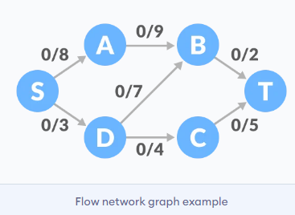
Step 1: Select any arbitrary path from S to T. In this step, we have selected path S-A-B-T
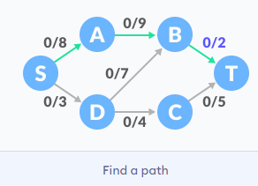
The minimum capacity among the three edges is 2 (B-T) Based on this, update the flow/capacity for each path.
Step2:Select another path S-D-C-T. The minimum capacity among these edges is 3(S-D)
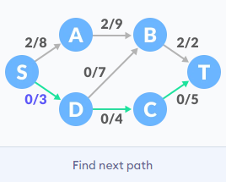
Update the capacities according to this.
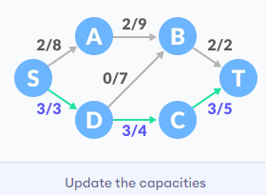
Step 3: Adding all the flows = 2 + 3 = 5, which is the maximum possible flow on the flow network.

Example 2:
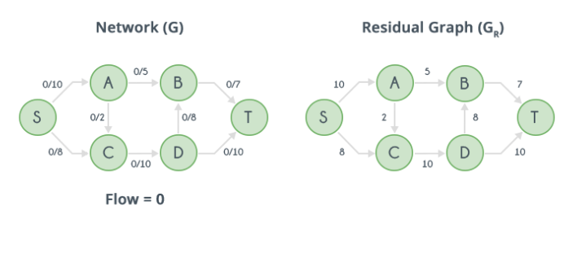
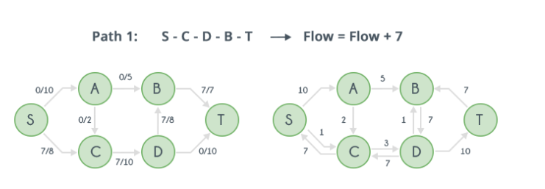
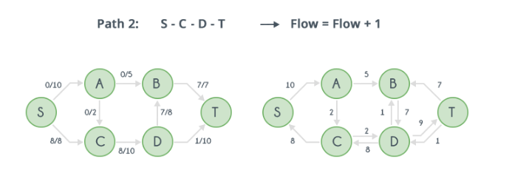
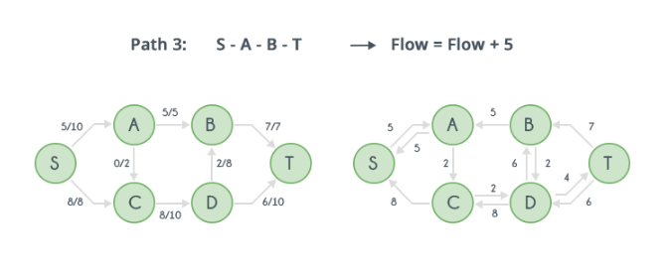
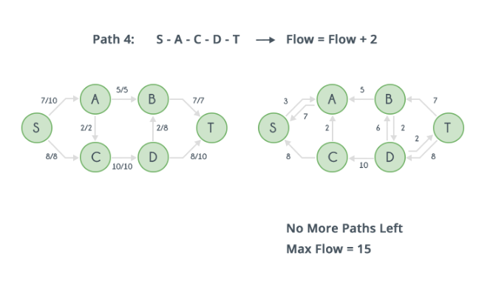

Java program for implementation of Ford Fulkerson algorithm:
MaxFlow.java
Input: 6
0 16 13 0 0 0  0 0 10 12 0 0  0 4 0 0 14 0  0 0 9 0 0 20  0 0 0 7 0 4  0 0 0 0 0 0  0 5 | 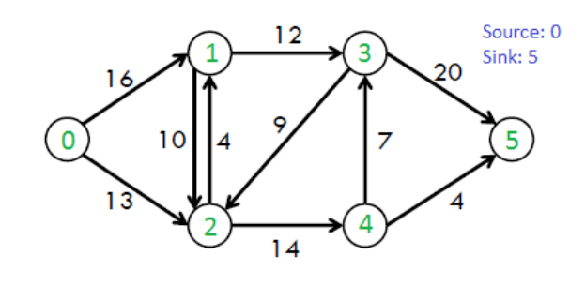
Output: 23
import java.io.*;
import java.lang.*;
import java.util.*;
import java.util.LinkedList;
/*
The following is simple idea of Ford-Fulkerson algorithm:
1) Start with initial flow as 0.
2) While there exists an augmenting path from the source to the sink:
a) Find an augmenting path using any path-finding algorithm, such as
breadth-first search or depth-first search.
b) Determine the amount of flow that can be sent along the augmenting path,
which is the minimum residual capacity along the edges of the path.
c) Increase the flow along the augmenting path by the determined amount.
3) Return the maximum flow.
*/
class MaxFlow
{
static int V; // Number of vertices in graph

/* Returns true if there is a path from source 's' to sink 't' in residual graph. Also fills parent[] to store the path */
boolean bfs(int rGraph[][], int s, int t, int parent[])
{
// Create a visited array and mark all vertices as not visited
boolean visited[] = new boolean[V];
for (int i = 0; i < V; ++i)
visited[i] = false;

// Create a queue, enqueue source vertex and mark source vertex as visited
LinkedList<Integer> queue = new LinkedList<Integer>();
queue.add(s);
visited[s] = true;
parent[s] = -1;

// Standard BFS Loop
while (queue.size() != 0)
{
int u = queue.poll();
for (int v = 0; v < V; v++)
{
if (visited[v] == false&& rGraph[u][v] > 0)
{
/* If we find a connection to the sink node, then there is no point in BFS anymore. We just have to set its parent and can return true*/
System.out.println("v " + v);
if (v == t)
{
parent[v] = u;
return true;
}
queue.add(v);
parent[v] = u;
visited[v] = true;
}
}
}
// We didn't reach sink in BFS starting from source, so return false
return false;
}
// Returns the maximum flow from s to t in the given graph
int fordFulkerson(int graph[][], int s, int t)
{
int u, v;
/* Create a residual graph and fill the residual graph with given capacities in the original graph as residual capacities in residual graph*/

/* Residual graph where rGraph[i][j] indicates residual capacity of edge from i to j (if there is an edge. If rGraph[i][j] is 0, then there is not)*/

int rGraph[][] = new int[V][V];

for (u = 0; u < V; u++)
for (v = 0; v < V; v++)
rGraph[u][v] = graph[u][v];

// This array is filled by BFS and to store path
int parent[] = new int[V];

int max_flow = 0; // There is no flow initially

// Augment the flow while there is path from source to sink
while (bfs(rGraph, s, t, parent))
{
/* Find minimum residual capacity of the edges along the path filled by BFS. Or we can say find the maximum flow through the path found.*/
int path_flow = Integer.MAX_VALUE;
for (v = t; v != s; v = parent[v])
{
u = parent[v];
path_flow = Math.min(path_flow, rGraph[u][v]);
}
// update residual capacities of the edges and reverse edges along the path
for (v = t; v != s; v = parent[v])
{
u = parent[v];
rGraph[u][v] -= path_flow;
rGraph[v][u] += path_flow;
}
// Add path flow to overall flow
max_flow += path_flow;
}
// Return the overall flow
return max_flow;
}

public static void main(String[] args)throws java.lang.Exception
{
Scanner sc=new Scanner(System.in);
V=sc.nextInt();
int graph[][] = new int[V][V];
for(int i=0;i<V;i++)
for(int j=0;j<V;j++)
graph[i][j]=sc.nextInt();

System.out.println(new MaxFlow().fordFulkerson(graph, 0, V-1));
}
}

Input = 6 //No. of Vertices
0 16 13 0 0 0
0 0 10 12 0 0
0 4 0 0 14 0
0 0 9 0 0 20
0 0 0 7 0 4
0 0 0 0 0 0
Enter source and sink
0 5
Output = 23

- Lowest Common Ancestor (Binary Tree):

- Given a tree G. Given queries of the form (v1,v2) for each query you need to find the lowest common ancestor (or least common ancestor), i.e. a vertex v that lies on the path from the root to v1and the path from the root to v2 and the vertex should be the lowest.
- In other words, the desired vertex v the most bottom ancestor of v1 & v2. It is obvious that their lowest common ancestor lies on a shortest path from v1 & v2. also, if v1 is the ancestor of v2, v1 is their lowest common ancestor.

Example:-
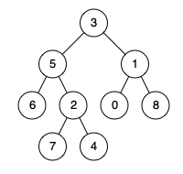
Input:-
3 5 1 6 2 0 8 7 4
5 1 //LCA(5,1)
Output:-
3
Explanation: The LCA of nodes 5 and 1 is 3, since a node can be a descendant of itself according to the LCA definition.
Input:-
3 5 1 6 2 0 8 7 4
5 4 //LCA(5,4)
Output:-
5
Explanation: The LCA of nodes 5 and 4 is 5, since one of the ancestor is a node itself.

Java Program for Implementing Lowest Common Ancestor:
LowestCommonAncestor.java
import java.util.*;
class Node{
public int data;
public Node left,right;
public Node(int value){
data=value;
left=null;
right=null;
}
}
public class LCA{
public static void main(String[] args){
Scanner sc=new Scanner(System.in);

String[] arr=sc.nextLine().split(" ");
String[] persons=sc.nextLine().split(" ");

List<Integer> v=new ArrayList<>();
int n=arr.length;
for(int i=0;i<n;i++){
v.add(Integer.parseInt(arr[i]));
}
Node P1=new Node(Integer.parseInt(persons[0]));
Node P2=new Node(Integer.parseInt(persons[1]));
Queue<Node> q=new LinkedList<>();
Node root=new Node(v.get(0));
q.add(root);
int j=1;
while(j<n && !q.isEmpty()){
Node temp=q.poll();
if(v.get(j)!=-1){
temp.left=new Node(v.get(j));
q.add(temp.left);
}
j++;
if(j<n && v.get(j)!=-1){
temp.right=new Node(v.get(j));
q.add(temp.right);
}
j++;
}
Node res=new Solution().lowestCommonAscendant(root,P1,P2);
System.out.println(res.data);
}
}
class Solution{
Node lowestCommonAscendant(Node root,Node P1,Node P2){
if(root==null || root.data==P1.data || root.data==P2.data)
return root;
Node left=lowestCommonAscendant(root.left,P1,P2);
Node right=lowestCommonAscendant(root.right,P1,P2);
return left==null ? right : right==null ? left : root;
}
}

Sample Test Case-1:
Input=3 5 1 6 2 0 8 -1 -1 7 4
6 4
Output=5

Sample Test Case-2:
Input=11 99 88 77 22 33 66 55 10 20 30 40 50 60 44
66 55
Output=11

Topological Sort

Applications:

      - Parallel Courses.
      - Course Schedule.
Introduction:

- Topological Sorting or Kahn's algorithm is an algorithm that orders a directed acyclic graph in a way such that each node appears before all the nodes it points to in the returned order, i.e. if we have a --> b, a must appear before b in the topological order.
- Its main usage is to detect cycles in directed graphs, since no topological order is possible for a graph that contains a cycle. Some of its uses are: deadlock detection in OS, Course schedule problem etc.
- The topological sort algorithm takes a directed graph and returns an array of the nodes where each node appears before all the nodes it points to.
- The ordering of the nodes in the array is called a topological ordering.
Example:
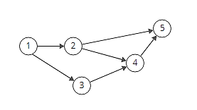
- Since node 1 points to nodes 2 and 3, node 1 appears before them in the ordering. And, since nodes 2 and 3 both point to node 4, they appear before it in the ordering.
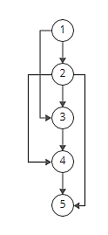
- So [1, 2, 3, 4, 5] would be a topological ordering of the graph.

Can a graph have more than one valid topological ordering? Yep! In the example above, [1, 3, 2, 4, 5] works too.

Why Topological Sort is not possible for graphs with undirected edges?
This is due to the fact that undirected edge between two vertices u and v means, there is an edge from u to v as well as from v to u. Because of this both the nodes u and v depend upon each other and none of them can appear before the other in the topological ordering without creating a contradiction.

Why Topological Sort is not possible for graphs having cycles?
Imagine a graph with 3 vertices and edges = {1 to 2 , 2 to 3, 3 to 1} forming a cycle. Now if we try to topologically sort this graph starting from any vertex, it will always create a contradiction to our definition. All the vertices in a cycle are indirectly dependent on each other hence topological sorting fails.

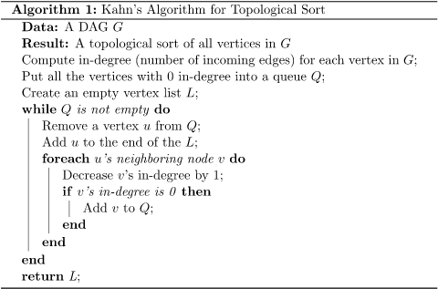

The Algorithm (explained with diagrams)

How can we produce a topological ordering for this directed graph?

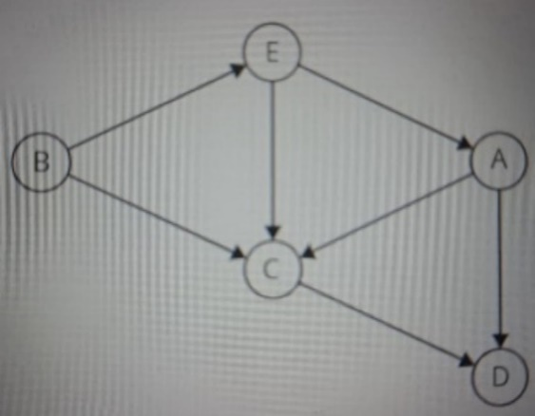

Well, let's focus on the first node in the topological ordering. That node can't have any incoming directed edges; it must have an indegree of zero.

Why?
Because if it had incoming directed edges, then the nodes pointing to it would have to come first.
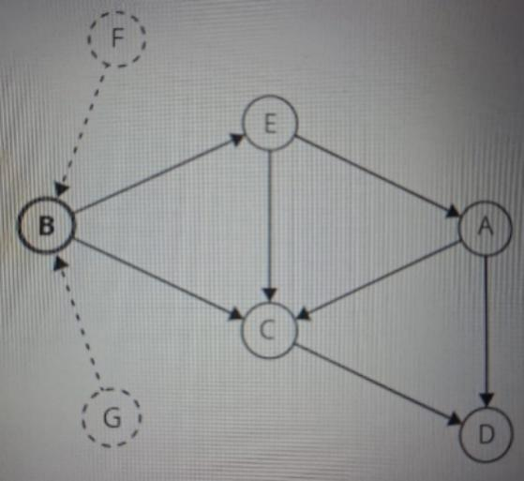

So, we'll find a node with an indegree of zero and add it to the topological ordering.

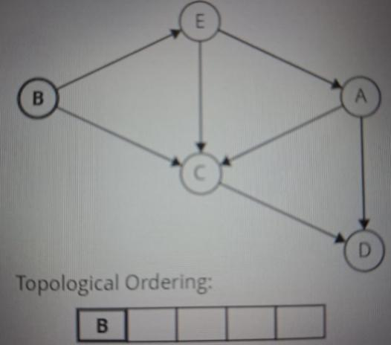
That covers the first node in our topological ordering. What about the next one?
Once a node is added to the topological ordering, we can take the node, and its outgoing edges, out of the graph.

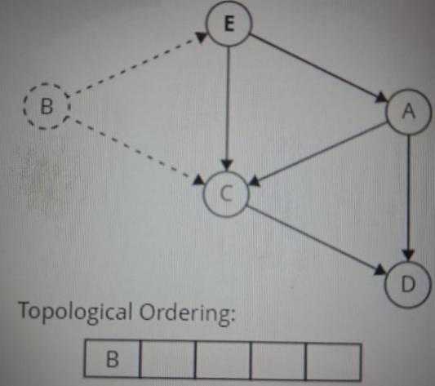

Then, we can repeat our earlier approach: look for any node with an indegree of zero and add it to the ordering.

Here's what this looks like on our graph. We'll grab a node with an indegree of 0, add it to our topological ordering and remove it from the graph:

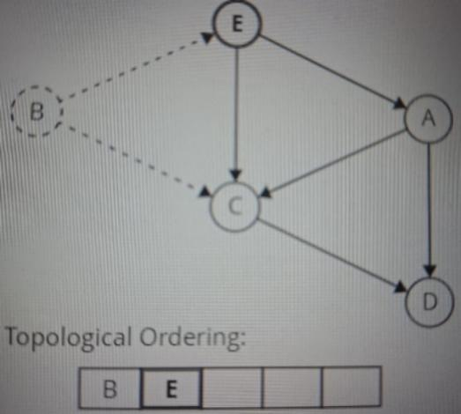
and repeat
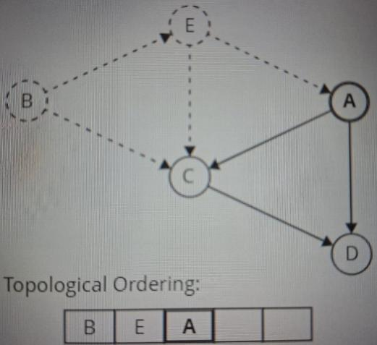
and repeat

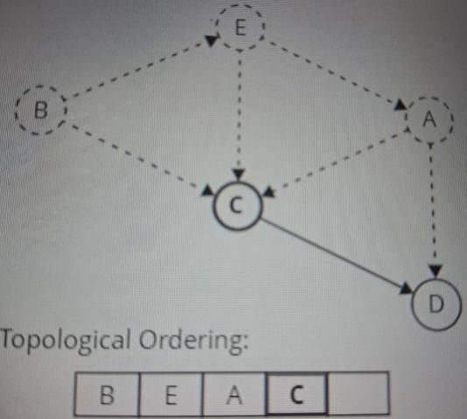

until we are out of nodes

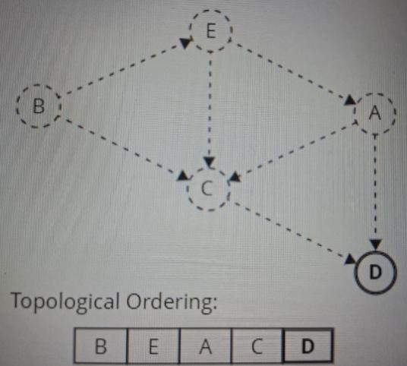

Key Characteristics of Topological Sort
Some key characteristics are listed below:
1. Works Only on DAGs: This algorithm can only be applied to a Directed Acyclic Graph (DAG). If the graph has a cycle, then topological sort is not possible.
2. Linear Ordering of Vertices: It helps to produce a linear sequence of vertices such that for every directed edge u -> v, vertex u comes before vertex v.
3. Multiple Valid Orders: A single graph may contain more than one valid Topological Sort. All of them fulfill the rule of dependencies.

4. First Vertex Has No Incoming Edges: The very first vertex always has an in-degree of 0. This means no other vertex points to it.
5. Preserves Dependency Order: This algorithm helps to ensure that all the dependencies are preserved. That is why it is useful for scheduling tasks, course planning, or compiling code.
6. Can be implemented using DFS or BFS: It can be performed using DFS (Depth First Search) and BFS (Breadth First Search). Both these methods give valid results.
Example:

Implementation using DFS:

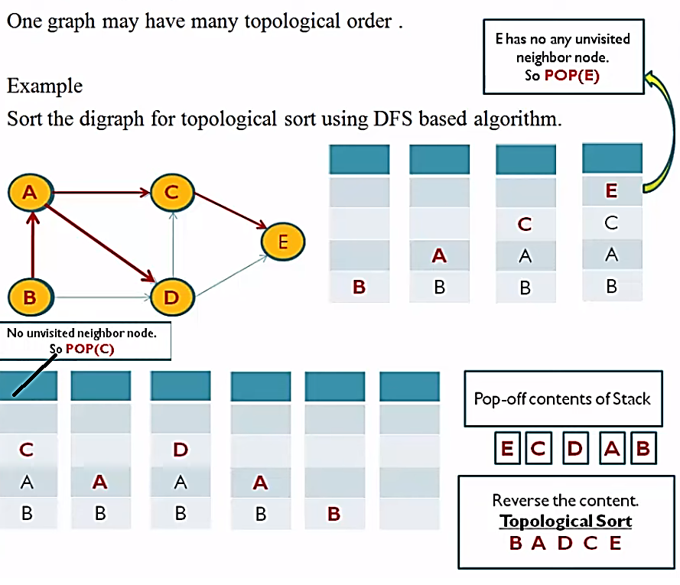

Topolological sort code
topologicalSort.java

// A Java program to print topological sorting of a graph using indegrees
import java.util.*;

// Class to represent a graph
class Graph
{
// No. of vertices
int V;
// An Array of List which contains references to the Adjacency List of each vertex
List<Integer> adj[];
// Constructor
public Graph(int V)
{
this.V = V;
adj = new ArrayList[V];
for (int i = 0; i < V; i++)
adj[i] = new ArrayList<Integer>();
}
// Function to add an edge to graph
public void addEdge(int u, int v)
{
adj[u].add(v);
}

/*
Step-1: Compute in-degree (number of incoming edges) for each of the vertex present
in the DAG and initialize the count of visited nodes as 0.

Step-2: Pick all the vertices with in-degree as 0 and add them into a queue (Enqueue operation)

Step-3: Remove a vertex from the queue (Dequeue operation) and then.

Increment the count of visited nodes by 1.
Decrease in-degree by 1 for all its neighbouring nodes.
If the in-degree of neighbouring nodes is reduced to zero, then add it to the queue.

Step 4: Repeat Step 3 until the queue is empty.

Step 5: If the count of visited nodes is not equal to the number of nodes in the
graph then the topological sort is not possible for the given graph.
*/

public void topologicalSort()
{
// Create a array to store indegrees of all
// vertices. Initialize all indegrees as 0.
int indegree[] = new int[V];
// Traverse adjacency lists to fill indegrees of
// vertices. This step takes O(V+E) time
for (int i = 0; i < V; i++)
{
ArrayList<Integer> temp = (ArrayList<Integer>)adj[i];
for (int node : temp) {
indegree[node]++;
}
}

for (int i = 0; i < V; i++)
{
System.out.println("vertex " + i + " indegree " + indegree[i]);
}

// Create a queue and enqueue all vertices with indegree 0
Queue<Integer> q = new LinkedList<Integer>();
for (int i = 0; i < V; i++)
{
if (indegree[i] == 0)
q.add(i);
}

// Initialize count of visited vertices
int cnt = 0;

// Create a list to store result (A topological ordering of the vertices)
List<Integer> topOrder = new ArrayList<Integer>();
while (!q.isEmpty())
{
// Extract front of queue (or perform dequeue)
// and add it to topological order
int u = q.poll();
System.out.println("Queue item " + u);
topOrder.add(u);

// Iterate through all its neighbouring nodes of
// dequeued node u and decrease their in-degree by 1
for (int node : adj[u])
{
System.out.println("adjacent items " + node);
// If in-degree becomes zero, add it to queue
if (--indegree[node] == 0)
q.add(node);
}
cnt++;
}
// Check if there was a cycle
if (cnt != V) {
//System.out.println("There exists a cycle in the graph");
return;
}
// Print topological order
for (int i : topOrder) {
System.out.print(i + " ");
}
}
}
class test
{
public static void main(String args[])
{
// Create a graph
Scanner sc=new Scanner(System.in);
int n=sc.nextInt();
Graph g = new Graph(n);
int e=sc.nextInt();
for(int i=0;i<e;i++){
int e1=sc.nextInt();
int e2=sc.nextInt();
g.addEdge(e1,e2);
}
g.topologicalSort();
}
}

            - Parallel Courses:

- You are given an integer N which denotes the number of courses numbered from 1 to N and a matrix ‘prerequisites’, in which each row contains exactly two integers ‘A’ and ‘B’ which represents the course ‘A’ has to be studied in some semester before studying course ‘B’.
- In one semester, you can take at most k courses as long as you have taken all the prerequisites in the previous semesters for the courses you are taking.
- You are supposed to find the minimum number of semesters required to study all the courses. If it is impossible to study all the courses, then return -1.
Note:
There is a limit on taking the number of courses in a particular semester as long as all the prerequisites for taking the course are satisfied.
Input Format:

- The first line represents N, which denotes the number of courses
- The second line represents M, which denotes the number of rows of the matrix prerequisites.
- The next M lines contain two integers, prerequisites[i][0] and prerequisites[i][1], denoting that prerequisites[i][0] has to be studied before prerequisites[i][1].
- Last line k, denotes number of courses can be taken in a semester.

Output Format:

- Print the minimum number of semesters required to study all the courses.
Input: n = 4,
m = 3
prerequisites =
2 1
3 1
1 4
k = 2
Output: 3
Explanation:
In the first semester, you can take courses 2 and 3.
In the second semester, you can take course 1.
In the third semester, you can take course 4.

Constraints:
1<= T <= 50
1 <= N <= 20000
0 <= M <= 20000
1 <= prerequisites[i][0], prerequisites[i][1] <= N
Prerequisites[i][0] != prerequisites[i][1], for any valid i
Java program for Implementing Parallel Course Application:
ParallelCourses.java

import java.util.*;
public class ParallelCourses
{
public int minimumSemesters(int numCourses, int[][] prerequisites,int maxCourses)
{
// create an adjacency list to represent the graph
int graph[][]=new int[numCourses+1][numCourses+1];
int[] indegree = new int[numCourses+1];
// populate the adjacency list using the prerequisites array
for (int[] prerequisite : prerequisites)
{
int u = prerequisite[0];
int v = prerequisite[1];
graph[u][v]=1;
indegree[v]++;
}
// Perform a topological sort to find the order in which the courses should be taken
Queue<Integer> queue = new LinkedList<>();
for (int i = 1; i < numCourses; i++)
{
if (indegree[i] == 0)
{
queue.offer(i);
}
}
int semesters = 0;
int coursesTaken = 0;
while (!queue.isEmpty())
{
int coursesThisSemester = Math.min(queue.size(), maxCourses);
for (int i = 0; i < coursesThisSemester; i++)
{
int u = queue.poll();
coursesTaken++;
for (int v=1;v<=numCourses;v++)
{
if(graph[u][v]==1&&--indegree[v] == 0)
queue.offer(v);
}
}
semesters++;
}
if (coursesTaken != numCourses)
{
return -1; // cannot complete all courses
}
return semesters;
}
public static void main(String[] args)
{
Scanner s=new Scanner(System.in);
int numCourses=s.nextInt();
int c=s.nextInt();
int prerequisites[][]=new int[c][2];
for(int i=0;i<c;i++)
{
for(int j=0;j<2;j++)
{
prerequisites[i][j]=s.nextInt();
}
}
int maxCourses=s.nextInt();
ParallelCourses p=new ParallelCourses();
System.out.println(p.minimumSemesters(numCourses,prerequisites,maxCourses));
}
}

Sample Test Case-1:
Input: 4
3
2 1
3 1
4 1
2
Output: 3

Sample Test Case-2:
Input:
4
3
1 3
2 3
3 1
3
Output:
-1

Course Schedule:

- There are n courses — course 0 to n-1. Some of them have prerequisites. For example, courses A and B must be completed before course C can be taken (in other words, course C depends on A and B).
- Find and return an order in which all the given courses can be taken, while satisfying all the prerequisites. If there exists more than one such order, any one of them would be a correct answer. If no such order exists, return a special value: [-1].

Example:

Notes:
- Function accepts two arguments: The number of courses n and the list of prerequisites.
- Prerequisites are given in the form of a two-dimensional array (or a list of lists) of integers. Each inner array has exactly two elements — it is essentially a list of pairs. Each pair [X, Y] represents one prerequisite: Course Y must be completed before X, X depends on Y).
- Function must return an array (list) of integers.
- If all given courses can be taken while satisfying all given prerequisites, the returned array must contain a possible ordering (if more than one such ordering exists, any one must be returned). Otherwise, the function must return an array (list) with one element -1 in it.
Input: n=4, List of prerequisites L = 4
prerequisites=
1 0
2 0
3 1
3 2
Output:
According to the input:
- Course 0 must be done before both 1 and 2
- Courses 1 and 2 must be done before course 3
There are two orders in which one can take all four courses: [0, 1, 2, 3] and
[0, 2, 1, 3]. Both are correct answers.
Approach:
- This is a Topological Sort problem. We’ll cover two efficient sample solutions: one uses DFS, while the second keeps track of the in-degree of the graph nodes. They have the same time and space complexity in the Big-O notation in terms of the number of courses and the number of prerequisites.
- Both algorithms need a directed graph to work with. So, let us build one.
  - Courses become graph nodes.
  - Prerequisites become directed edges: for each “course A must be completed before B can be taken,” we add an edge from A->B. In other words, an incoming edge means that another course must be completed before this one.
For example, if n=4 and prerequisites= [[1, 0], [2, 0], [3, 1], [3, 2]], the graph would look like this:
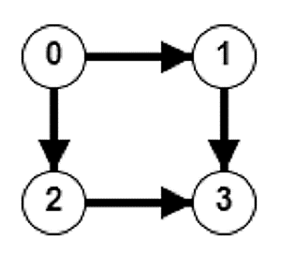
- The correct answer to the problem will be a topological order of the nodes. The two sample solutions discussed below are essentially two different implementations of the topological sort algorithm.
- Topological ordering doesn’t exist if the graph has a cycle. Both sample solutions detect cycles in their respective ways and return the special value in that case.

Java Program for Implementing Course Schedule Application:
CourseSchedule.java

import java.util.*;
import java.io.*;
class CourseSchedule
{
public int[] findOrder(int numCourses, int[][] prerequisites)
{
// just do topological ordering
// n courses: ranging from 0 to n-1
// also need to construct a graph according to the prerequisites
List[] graph = new ArrayList[numCourses];
for (int i = 0; i < numCourses; i++)
graph[i] = new ArrayList<Integer>();

int[] indegree = new int[numCourses];
for (int[] p : prerequisites)
{
int u = p[1], v = p[0]; // from u->v
graph[u].add(v);
indegree[v]++;
}

int[] order = new int[numCourses];
int index = 0;
Queue<Integer> queue = new LinkedList<Integer>();
for (int i = 0; i < numCourses; i++)
{
if (indegree[i] == 0) queue.add(i);
}

// start from indegree=0, add the neighbors to the queue
// if indegree becomes 0, add to queue
while (!queue.isEmpty())
{
int u = queue.poll();
order[index++] = u;
for (int v : (List<Integer>)graph[u])
{
if (--indegree[v] == 0)
{
queue.add(v);
}
}
}

// in case there are cycles in the graph
if (index < numCourses)
return new int[0];

return order;
}
public static void main(String args[] ) throws IOException
{
Scanner sc=new Scanner(System.in);
int courses,nprerequisites;
courses=sc.nextInt();
nprerequisites=sc.nextInt();
int[][] prerequisites=new int[nprerequisites][2];
for(int i=0; i<nprerequisites; i++)
{
int a=sc.nextInt(),b=sc.nextInt();
prerequisites[i][0]=a;
prerequisites[i][1]=b;
}
int[] result=new CourseSchedule().findOrder(courses, prerequisites);
System.out.println(Arrays.toString(result));
}
}

Sample Test Case-1:
Input:
4
3
1 2
3 0
0 1
Output:
[2, 1, 0, 3]

Sample Test Case-2:
Input:
5
4
2 4
3 1
0 2
4 3
Output:
[1, 3, 4, 2, 0]

